**Types of Machine Learning (Production Bases)**

1. Batch ML
2. Online ML
3. **Batch ML:** is you train your entire data on your machine in one go and then deploy you model on the server.

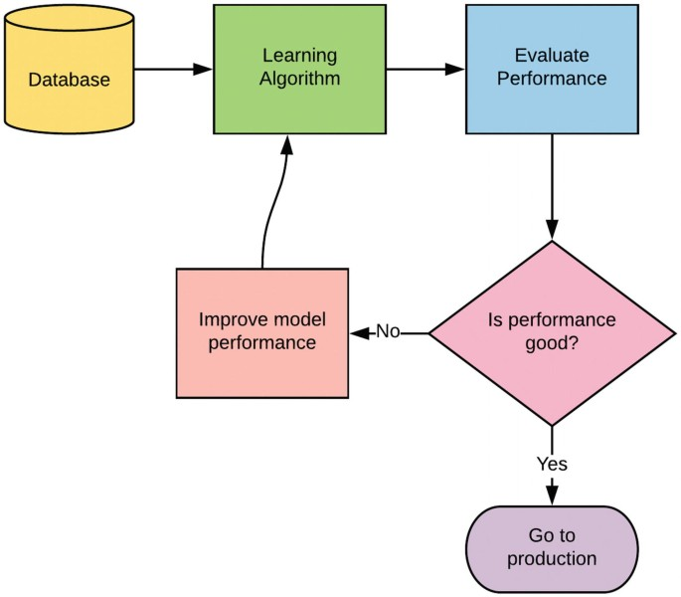

Problem with this learning is that once your model trained is goes on with old training. You have to retrain it periodically. More problems as below

Lots of Data

Hardware Limitation

Availability

1. **Online ML:** Have you ever listen that some companies claims that the amount of our product you will use it will start improving. Means improvement occurs due to useability. Those companies are using online machine learning. So, when our model dynamically trained with new data on the server or in production scenario is called online machine learning.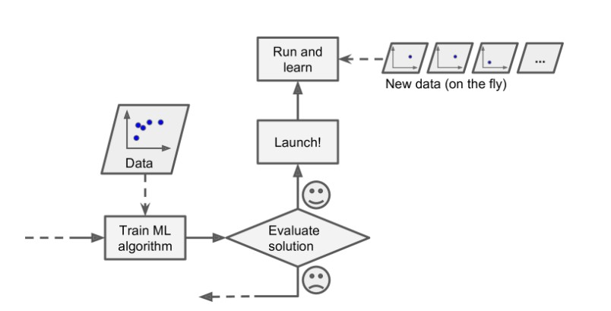

You start with small data and trained it check it. Then put it on the server. Then your model trained with small batch of data online and improving themselves. Examples are chat bots, YouTube etc.

When to use online machine learning.

When concept drift

Cost effective

Faster Solution

River, Scikit and vowpal wabbit are best libraries for online machine learning.

**Learning Rate in Online ML**: You have maintained correct learning rate to avoid forgetting the older learning.

**Out Core Learning**: When you have huge dataset and you have hardware limitation. Then you can split the data into small batches and train it.

Problems:

Tricky to use (New in market)

Risky (Spammer may do something to biased your data)